[**https://www.youtube.com/watch?v=fIomfjGo4Qs**](https://www.youtube.com/watch?v=fIomfjGo4Qs) **Create new app**

**Create data model on paper  
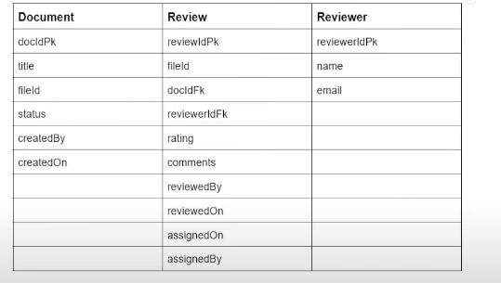**

**1st step – create tables (data model)**

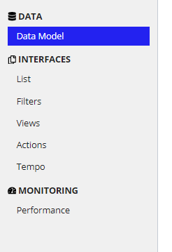

Connect with a scratch database

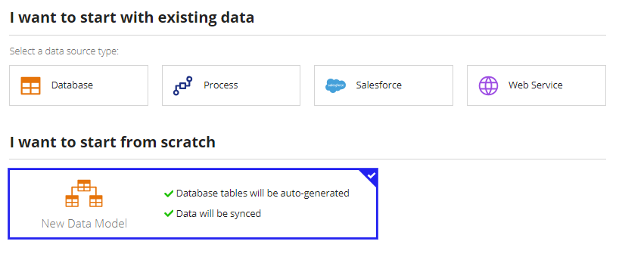

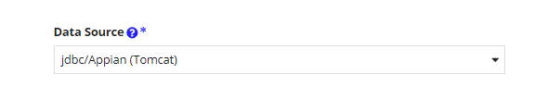

**Create all 3 models**

**3. Create relationships. Many reviews can have on reviewer**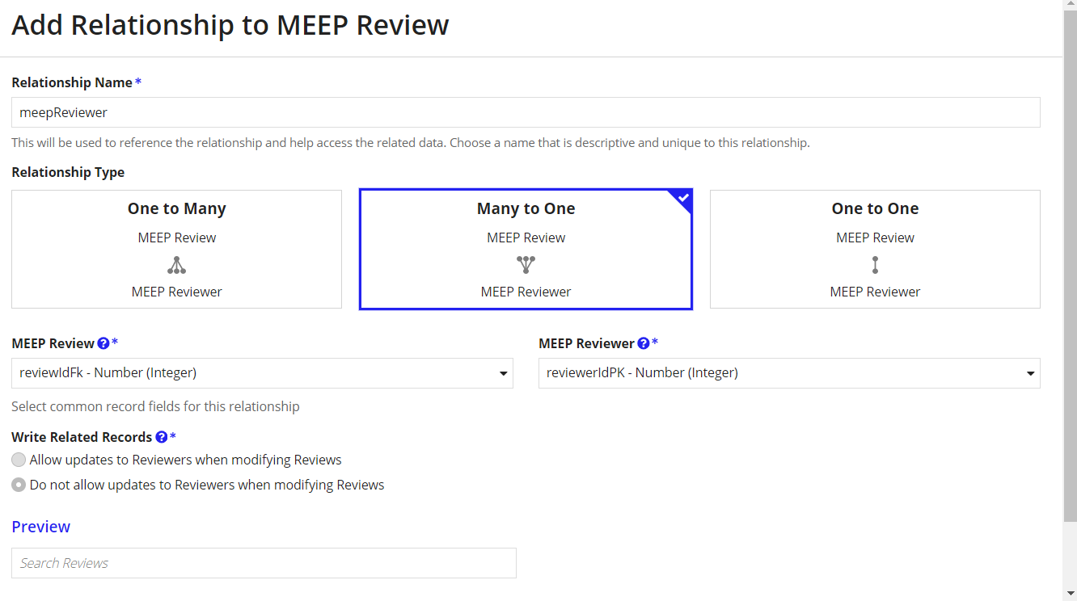

**4. Create interface**

**Create a rule input to store data in DR document (add document table in type)**

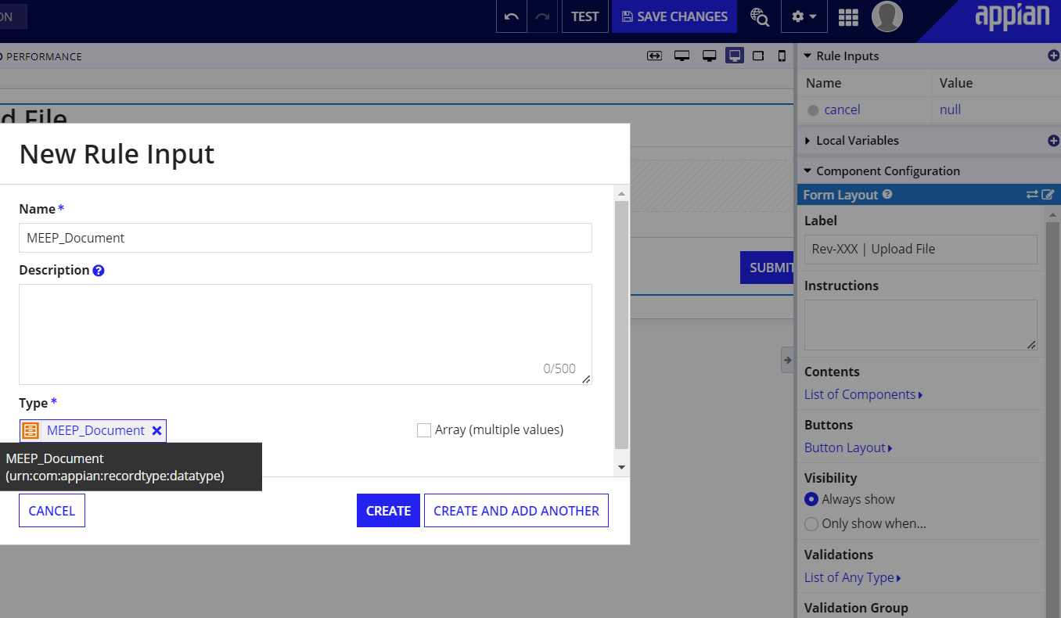

Go to expression mode

And a value to be saved into the Document table.title  
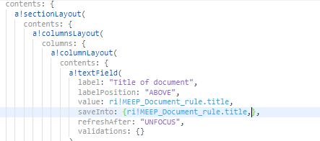

[Double check this with Faizan Rabia – mine (above) looks different]

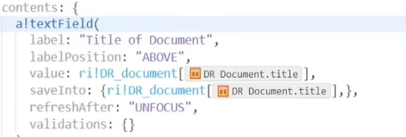

To save the files in Appian, go to knowledge center and make a new folder: 

Create a constant with the same name

Then create a constant to refer to the folder.

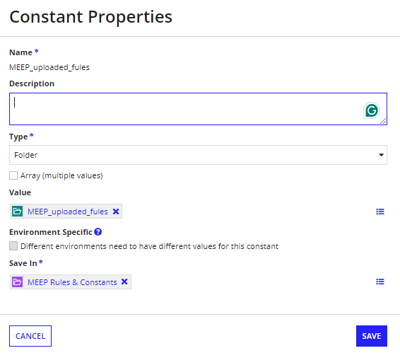

For the file upload add the constant as the target and the value + saveInto as Rule Input

Add max selection rule so only one file can be uploaded at a time

And validate that the extension is a pdf file

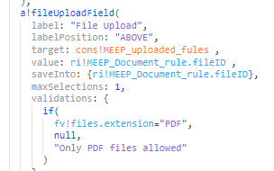

Create a process model in order to upload the data into DB

MEEP_upload_files

Keep default settings

And go in an add two swim lanes instead of the default one: 

Add the MEEP_uploadFile to the form lane and open it up

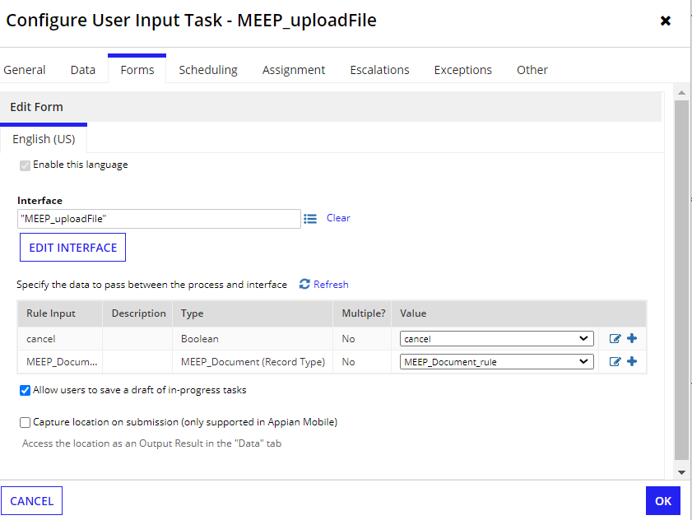

Uncheck the draft option